**Introduction To Computer Hardware**

All physical components that make up a computer is known as computer hardware.It includes all components that we can see and touch i.e. processor, input devices like keyboard, mouse, output devices like visual display unit (VDU), printer, speaker, connecting wires, casing, storage devices etc.

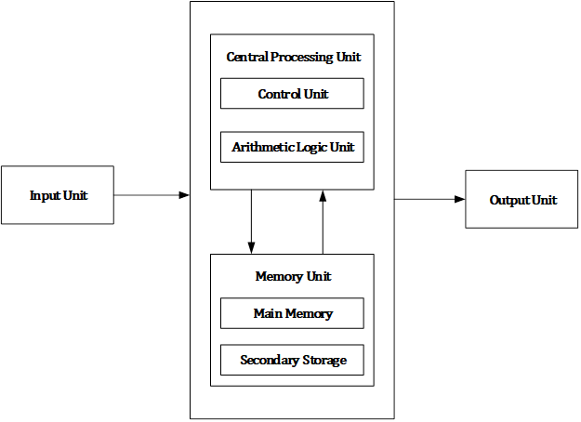

Computer hardware consists of different functional units: input unit, central processing unit (CPU) which consists arithmetic logic unit (ALU) and control unit (CU), memory unit and output unit.

**Major components of a computer system**

1.Mother Board

Alternatively referred to as the mb, mainboard, mboard, mobo, mobd, backplane board, base board, main circuit board, planar board, system board, or a logic board on Apple computers. The motherboard is a printed circuit board and foundation of a computer that is the biggest board in a computer chassis. It allocates power and allows communication to and between the CPU, RAM, and all other computer hardware components.

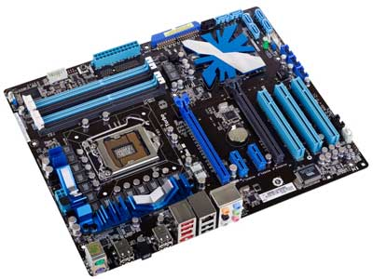

The motherboard is mounted inside the case and is securely attached via small screws through pre-drilled holes. Motherboard contains ports to connect all of the internal components. It provides a single socket for CPU, whereas for memory, normally one or more slots are available. Motherboards provide ports to attach the floppy drive, hard drive, and optical drives via ribbon cables. Motherboard carries fans and a special port designed for power supply.

There is a peripheral card slot in front of the motherboard using which video cards, sound cards, and other expansion cards can be connected to the motherboard.

On the left side, motherboards carry a number of ports to connect the monitor, printer, mouse, keyboard, speaker, and network cables. Motherboards also provide USB ports, which allow compatible devices to be connected in plug-in/plug-out fashion. For example, pen drive, digital cameras, etc.

2.Ram Modules

In computing, a memory module or RAM (random-access memory) stick is a printed circuit board on which memory integrated circuits are mounted. Memory modules permit easy installation and replacement in electronic systems, especially computers such as personal computers, workstations, and servers.

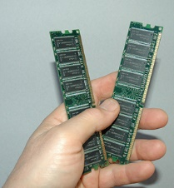

It can be thought of like a computer's short term memory. It works by storing common data that programs are in constant use of, rather than storing the data on a much slower medium like a Solid State Hard Drive (or SSD). RAM doesn't automatically have data saved on each chip though.

3.Daughter Cards

A daughtercard or [daughterboard](https://www.easytechjunkie.com/what-is-a-daughterboard.htm) is a type of [circuit board](https://www.easytechjunkie.com/what-is-a-circuit-board.htm) that gets added to an existing one. Its name is appropriate for its use, since it is connected to a “[motherboard](https://www.easytechjunkie.com/what-is-a-motherboard.htm)” or “main board.” The motherboard is the primary circuit board for a device. It is usually in the device as it is shipped from the factory. A daughtercard may be added later.

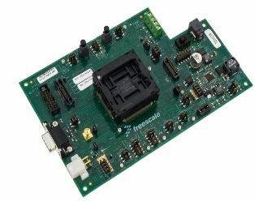

4.Bus Slots

Alternatively known as a bus slot or expansion port, an expansion slot is a connection or port inside a computer on the motherboard or riser card. It provides an installation point for a hardware expansion card to be connected.

Expansion slots have what's called data lanes, which are signaling pairs that are used for sending and receiving data. Each pair has two wires, which makes a lane have a total of four wires. The lane can transfer packets eight [bits](https://www.lifewire.com/definition-of-bit-816250) at a time in either direction.

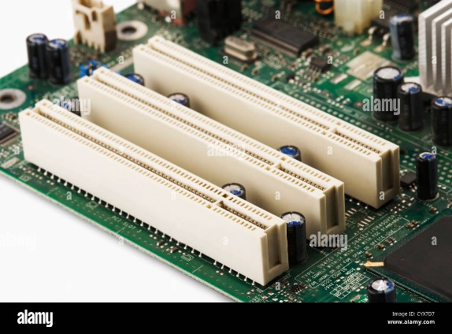

5.SMPS

SMPS is an electronic power supply system that makes use of a switching regulator to transfer electrical power effectively. It is a PSU (power supply unit) and is usually used in computers to change the voltage to the appropriate range for the computer.

A switched-mode power supply (SMPS) can be understood as an electronic circuit converting power with switching devices that turn on and off at high frequencies. They are also storage component like inductors or capacitors that supplies power when the switching as at its non-conduction state

The advantages of SMPS include, The efficiency is as high as 80 to 90% Less heat generation; less power wastage. Reduced harmonic feedback into the supply mains.

The SMPS device uses switching regulators that switches the load current on and off to regulate and stabilize the output voltage. The average of the voltage between the off and on produces the appropriate power for a device. Unlike the linear power supply, the pass transistor of SMPS switches between low dissipation, full-on and full-off mode, and spends very less time in the high-dissipation transitions, which minimizes wasted energy.

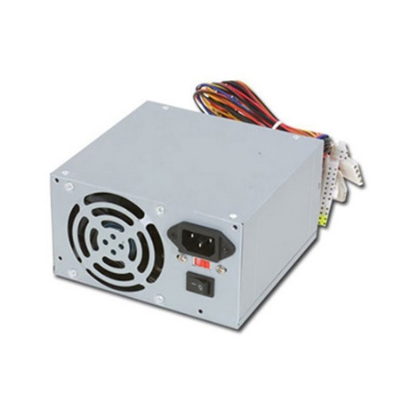

6.Internal Storage Devices

Internal storage allows the data and applications to be loaded very rapidly into memory, ready for use. The data can be accessed much faster than data which is stored on an external storage device. This is because internal storage devices are connected directly to the motherboard and its data bus whereas external devices are connected through a hardware interface such as USB, which means they are considerably slower to access.

It will also be used to store the applications software that you use and more Than Likely, the original copies of your data files.

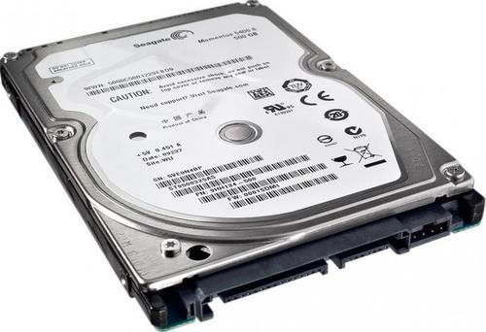

7.Interfacing Ports

A port is a hardware interface that connects devices together. The port transfers electrical signals between the device and the computer. For example, an electrical wired plug.

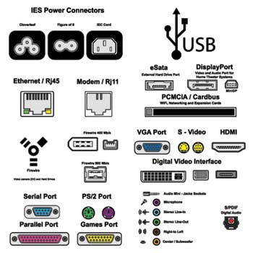

Serial Port

* Used for external modems and older computer mouse
* Two versions: 9 pin, 25 pin model
* Data travels at 115 kilobits per second

Parallel Port

* Used for scanners and printers
* Also called printer port
* 25 pin model
* IEEE 1284-compliant Centronics port

PS/2 Port

* Used for old computer keyboard and mouse
* Also called mouse port
* Most of the old computers provide two PS/2 port, each for the mouse and keyboard
* IEEE 1284-compliant Centronics port

Universal Serial Bus (or USB) Port

* It can connect all kinds of external USB devices such as external hard disk, printer, scanner, mouse, keyboard, etc.
* It was introduced in 1997.
* Most of the computers provide two USB ports as minimum.
* Data travels at 12 megabits per seconds.
* USB compliant devices can get power from a USB port.

VGA Port

* Connects monitor to a computer's video card.
* It has 15 holes.
* Similar to the serial port connector. However, serial port connector has pins, VGA port has holes.

Power Connector

* Three-pronged plug.
* Connects to the computer's power cable that plugs into a power bar or wall socket.

Firewire Port

* Transfers large amount of data at very fast speed.
* Connects camcorders and video equipment to the computer.
* Data travels at 400 to 800 megabits per seconds.
* Invented by Apple.
* It has three variants: 4-Pin FireWire 400 connector, 6-Pin FireWire 400 connector, and 9-Pin FireWire 800 connector.

Modem Port

* Connects a PC's modem to the telephone network.

Ethernet Port

* Connects to a network and high speed Internet.
* Connects the network cable to a computer.
* This port resides on an Ethernet Card.
* Data travels at 10 megabits to 1000 megabits per seconds depending upon the network bandwidth.

Game Port

* Connect a joystick to a PC
* Now replaced by USB

Digital Video Interface, DVI port

* Connects Flat panel LCD monitor to the computer's high-end video graphic cards.
* Very popular among video card manufacturers.

Sockets

* Sockets connect the microphone and speakers to the sound card of the computer.

**Specifications Of Desktop And Server Class Computers**

When multithreaded operating system processes are not available, a good alternative is to use a set of processes to emulate a pool of threads. That is, instead of having one multithreaded process, the system uses a set of single-threaded processes, all of which are running the same program . This often is called a **server class**. In this case, for each server program, there is a set of server processes that runs it.

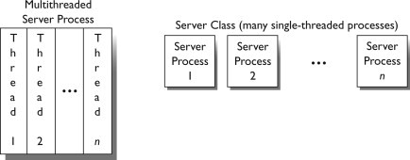

### PC Desktop Hardware Specifications

* **Motherboard:** Gigabyte B560M-DS3H Motherboard
* **Power Supply:**Scaled appropriately to support delivered system with reasonable growth potential (In Win CE685 PC case with 300 watt 80PLUS certified power supply)
* **Case:**In Win CE685 PC case with 300 watt 80PLUS certified power supply
* **CPU:** Intel Core i5-11400 Processor
* **RAM:**8GB DDR4 2666 (PC4 21333) RAM (1 8GB DIMM)
* **NIC:**On-board 10/100/1000 Mbps based Ethernet NIC
* **HDD:** 250 GB Western Digital M.2 NVMe SSD Part # WDS250G2B0C
* **Video:**Integrated Intel HD Graphics with DVI Digital Output Interface
* **Optical Drive:** (optional)
* **Audio:** Onboard HD audio
* **Externally powered Satellite Speakers:**(optional)
* **6 External Powered USB Ports and 2 on front of case**
* **Operating System:**Microsoft Windows 7 Home Basic(or other least expensive Microsoft Windows operating system)
* **All appropriate cables necessary**
* **HIDs:** USB Optical mouse, mouse pad, USB keyboard, all necessary cables
* **3 year parts and labor warranty on all components**
* **Monitor:** 20″ Wide Screen LCD Monitor (1920×1080 native resolution) with DVI Digital Input Interface

### PC Laptop Specifications

There is currently 1 laptop model specified for new purchases

* Intel Core i5-1135G7 Processor
* 8GB DDR4 2666 RAM
* 250 GB M.2 NVMe Solid State Drive
* 15.6″ Wide Screen Display
* Microsoft Windows Windows 7 Pro(or other least expensive Microsoft Windows operating system)
* On board 10/100/1000 Mbps Ethernet NIC
* On board Wireless NIC
* On board HD Audio
* 2 External powered USB Ports
* Padded Carry Case appropriate for delivered model
* Appropriate American Power Conversions Notebook Surge Suppressor for delivered model
* All appropriate cables necessary
* 3 year parts and labor warranty on all components

Any laptop purchase should also include a case.

Additionally, any laptop purchase should also include inline surge-suppression:

* [2 pin APC Notebook Surge Protector](http://www.apc.com/resource/include/techspec_index.cfm?base_sku=PNOTEPROC8)
* 3 pin APC Notebook Surge Protector